Lecture 2
Modular Programming - Split a big program into smaller pieces called modules. Each module contains functions that do one task.
Object-Oriented Programming (OOP) - OOP organizes programs around objects, not functions.
Modular Programming | OOP
program organized around functions | program organized around objects
data and functions are separate | data + functions inside objects
common in C | common in Java, C++, Python

Terminology for classes:
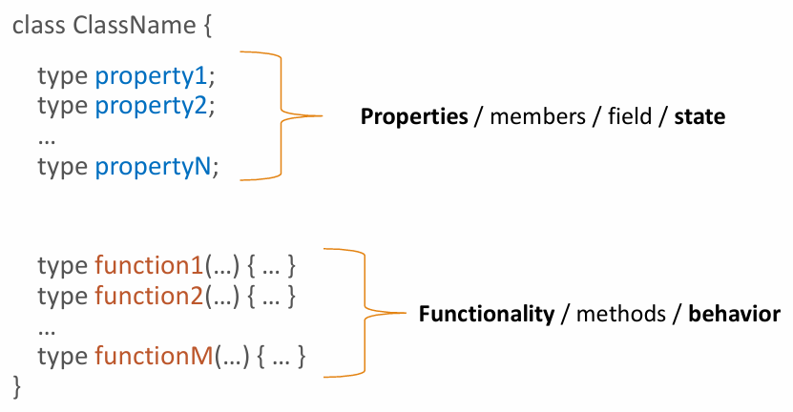
Note about naming: If class is declared as public, it should be saved in a file with the same name. If you have several classes in one file, then make sure that exactly one (optional: with the main() method) is declared as public.
In class names words start with capital letter , like MyFirstClass or DataOrganizer. Do not use UPPERCASE, underscore (“_”) in class names.
There can be more than one method with the same name within the same class, if and only if:
1. Different number of input parameters
2. The same number of input parameters with different (opt: order of) data types.
After that, method overloading happens.
For method to accept non-know amount of parameters use varargs. It’s exactly same as C# params keyword.

Access Modifiers
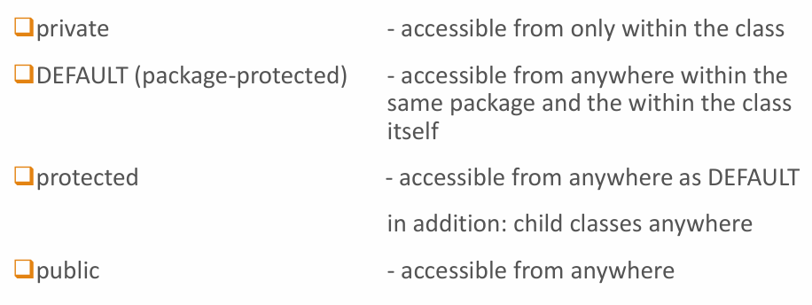
The difference between DEFAULT (package-protected) and protected is mainly about inheritance (child classes):
The DEFAULT - So classes in the same package can access it. But classes outside the package cannot, even if they extend the class.
Protected – child classes can access even outside the package.

Reference
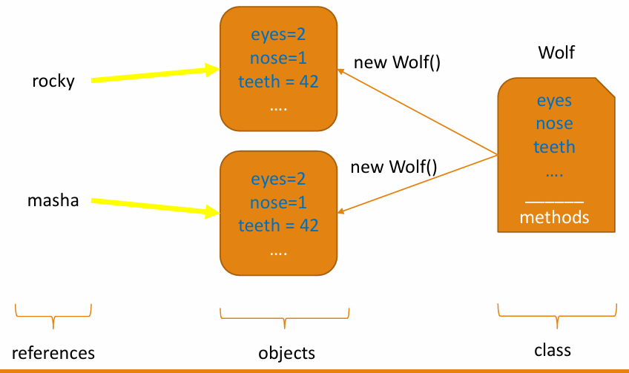
someName is not an object – it is a reference to the created object:
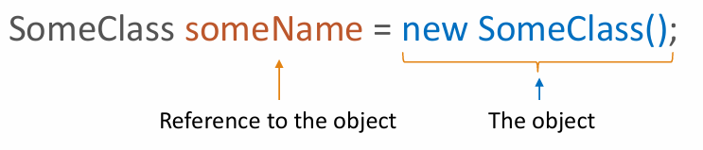
In below example, both variables refer to the same object and changing the value of one, will impact another as well:
Wolf alex = new Wolf();
Wolf fred = alex;
System.out.println(“Alex has “+alex.teeth+” teeth”); // 42
System.out.println(“Fred has “+fred.teeth+” teeth”); // 42
alex.teeth = 35;
System.out.println(“Alex has “+alex.teeth+” teeth”); // 35
System.out.println(“Fred has “+fred.teeth+” teeth”); // 35
The diagram for it:
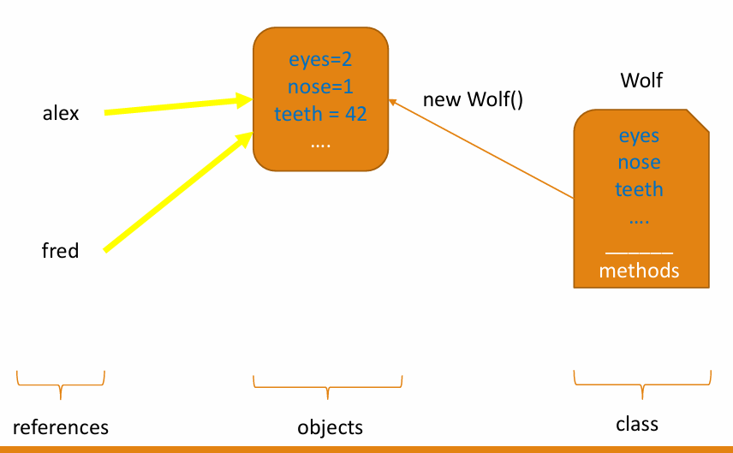

Constructors
empty constructor = default constructor
Note: constructors are not methods (functions).
copy constructor
class Wolf { // members declared here.
Wolf() { /* an empty constructor */}
Wolf(String color) { /* constructor that sets wolf’s color upon creation */ } Wolf(int eyeCnt, String color) { /* eyes and color are set */}
Wolf(Wolf anotherWolf) { /* making a copy of a wolf object */
eyeCnt = anotherWolf.eyeCnt;
color = anotherWolf.color; //this applies to all the fields
}
// remaining code
}
Calling the copy constructor:
// With the copy constructor
Wolf copyOfJax = new Wolf(jax);

“this” keyword helps refer to the object itself inside the class code:

Encapsulation
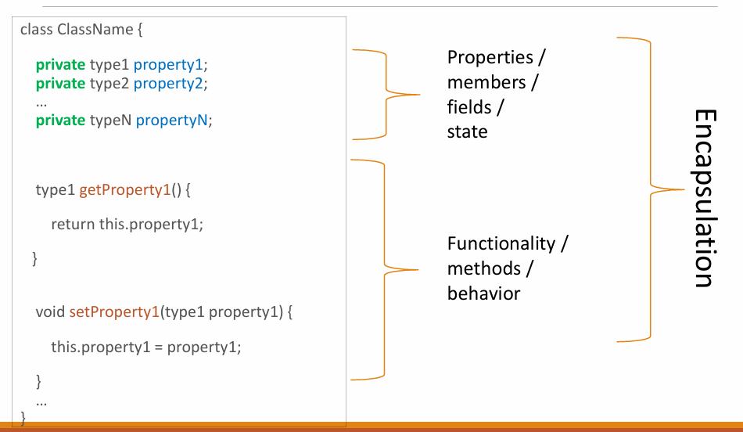
Encapsulation = hiding internal data and controlling access to it. And getter and setters allow controlled access. That’s why encaps -> private+get/set

Association -> relationship between objects of different types.
There are two types of association: aggregation and composition .
Aggregation: in this type of relationships the objects involved do not necessarily need each other to survive. Example: Car and Windshield Wiper
Composition: in this type of relationships the objects involved strongly dependent on each other, one cannot survive without the other. Example: House and Dining Room
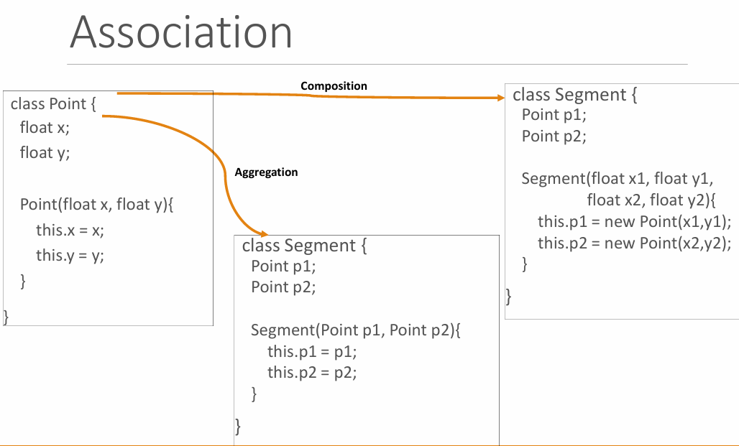
In 1st Segment does NOT create the points. The points already exist somewhere else and are passed into the constructor. Points exist independently from Segment. Even if the Segment disappears, Point a and Point b still exist. Segment USES Points but does not own them
In 2nd Segment creates the points itself. They cannot exist separately. If the Segment disappears, p1 and p2 disappear too. Segment OWNS the Points.
Feature | Aggregation | Composition
Who creates objects | outside class | inside class
Object independence | objects exist independently | objects depend on parent
Relationship | "has-a" | "part-of" strong ownership

UML(Unified Modeling Language):
Use-case diagrams - are used to graphically represent how users and software (system) interacts.
Class diagrams - are used to graphically represent the structure of the system by showing its classes, and ◦ Their attributes and behavior ◦ Relationships between these classes and objects. The members of the class can be either instance or static. The only difference is the static is represented in underlined in this software.
